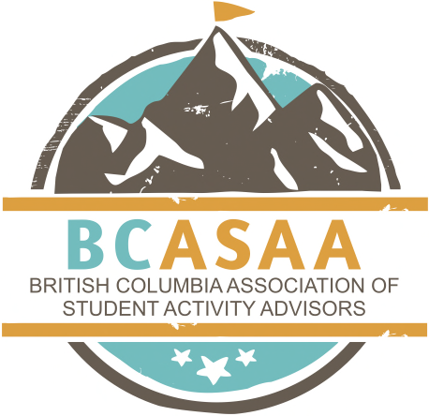
Membership Application Form
Membership to the British Columbia Association of Student Activity Advisors is set at $40 for the school year. Membership allows you:
 access resources / activities on the website
 access several leadership books on the website
 access to archived documents such as newsletters and presenter’s handouts  access to attend the BCSLC and Advisor Conference
 connections to other leadership teachers  potential deals on speakers travelling through BC
 network with some of the top leadership teachers from across the country
Please fill out the information below and remit a $40.00 cheque payable to BCASAA attention to:
Doug Primrose – President 36224 Shadbolt ave
Abbotsford, BC
V3G3C4
Please print legibly.
Name: (first) (last) E-mail address:
School:
Address:
Street and Number: City:
Phone #:
Home:
Fax #:
Postal Code:
Work:

